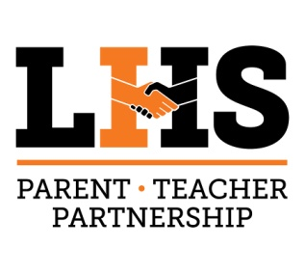
LHS PTP
Dreadnaught Closet Supply List
(updated spring 2018)

Toiletries:
Shampoo and conditioners
Body soap: bar or body wash
Toothbrush and paste
Deodorant
Lotion
Hair brushes
Small boxes of Q-tips
Small first aid to go kits
Nail clippers
Pads / tampons
Hand sanitizer
Wash cloths
Towels
Small travel pillows and cases
Lap blankets
Face Wash

Clothing:
New or gently used clothing appropriate for teens
Socks
Dreadnaught clothing is a big hit
Jackets: zipper fronts or pull-overs
Shoes: gently used various size ranges
Bags:
Backpacks ( gently used)
Draw string backpacks
Reusable tote bags
School supplies:
Locks for lockers and bike locks
Notebook paper
Pencils
Pens
Folders with brads
3 rind binders- 1 inch
Colored pencils
Colored markers
Note cards
Spiral notebooks
Highlighters
Glue sticks
USB Drives
Graph Paper
Calculator
Planner/Agenda
Snacks:
Breakfast bars
Cracker w/ cheese and peanut butter in them
Fruit snacks
Can soups and fruits
Small boxes of cereal
Can meat or packages of meat (chicken and tuna...etc)
Ritz crackers

